


Org Credential Setup for Developers



Document Control Information
Document Information
Document Name | Org Credential Setup for Developers
Project Name | Humana Salesforce DevOps
Client | Humana
Document Author | Regin Kanagappa
Document Version | 1.0
Document Status | Release
Date Released | 4/16/2021
Document Edit History
Version | Date | Additions/Modifications | Prepared/Revised by
Document Review/Approval History
Date | Name | Organization/Title | Comments

Table of Contents
1. Org Credential Setup for Developers 4

Org Credential Setup for Developers

- An org credential is a connection between a user and a Salesforce environment
To become an active user in the Copado environments, you need to set up an 'Org Credential'.
Below are the steps to create your own Org Credentials in Copado.
- Click on the 'Org Credentials' Tab and click on ‘New’ Button towards top right.
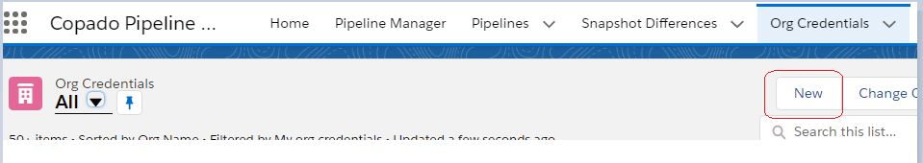

- Enter the following information. Important, Please select Custom Domain:
Org Name: TeamName_FirstName_LastName –
For eg, if you are from Clinical team of ECOM org, it should be Clinical_FirstName_Lastname
Org Type: Custom Domain
Custom Domain: https://humanashared.my.salesforce.com
Note, please use https://humanashared--copadotrn.my.salesforce.com as Custom Domain if you are setting up the Training Environment (CopadoTrn)
Everything else should remain default. Then click on the ‘SAVE’ button.

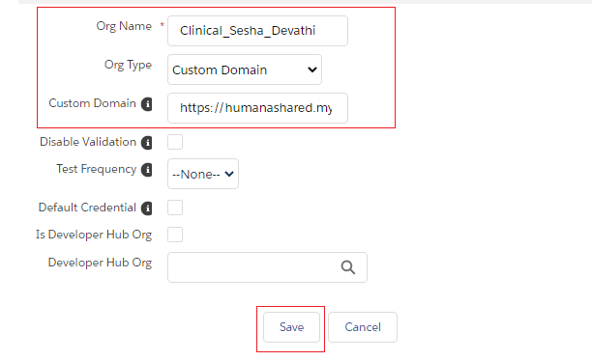
- Click on the 'Authenticate' button on top left.
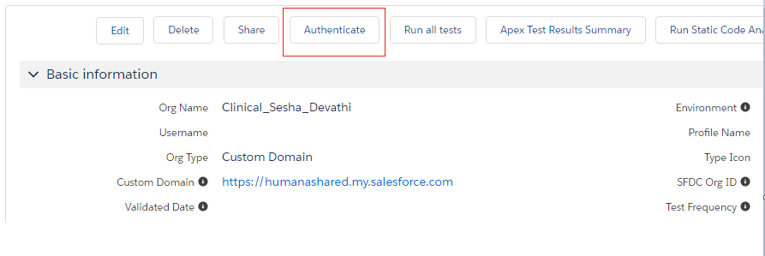
- This will open a new tab asking for login, click on ‘Copado SSO’
Note, if you do not see the 'Copado SSO' as shown in image, please make sure that you have selected Custom Domain as Org Type in Step 2.

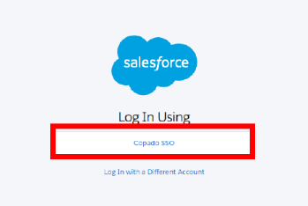
- You will be directed to a new Page, click on ‘Allow’.
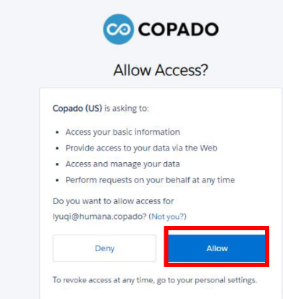
- Allow a few minutes for the page to load. You will be directed to a few different pages. Once loading is finished, click on 'Save'
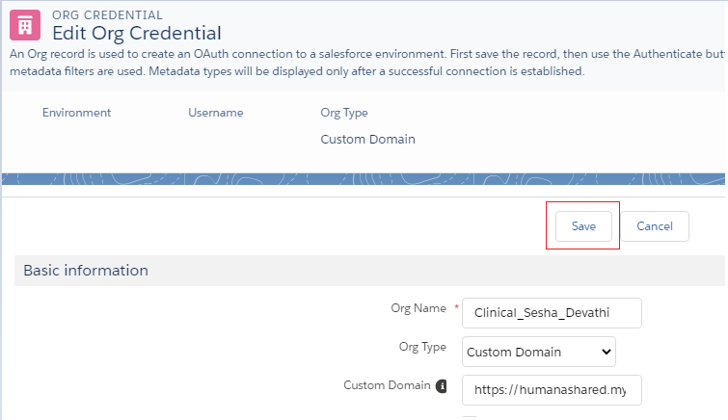
- After the 'Loading' popup goes away (takes a little bit of time), you have successfully created your Org Credential to the Copado environment. Disregard the ‘insufficient access’ reminder. You will see a green bar on top and no other credentials are needed. You will leverage the other ones already setup for different projects going forward.

